C.V
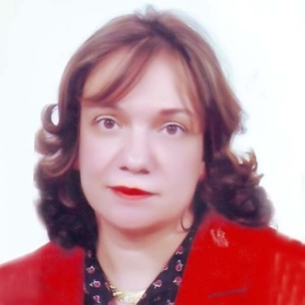
Name: Mariam Zakaria Wahba Michael
Date of birth: 09/06/1961
Nationality: Egyptian
Graduation:
1-Faculty of Medicine (Cairo University) in 1986
2-Faculty of Science (Cairo University) in 1983 ( Anatomy and Physiology)
Courses:
1- Ultrasonography.
2- Laboratories.
3- E-Marketing , E- Commerce, Export- Import Specialist ( Cairo University) and ( Faculty of Computers and Information Technology Club) from 02/07/2011 to 23/07/2011
4- IVF and IUI.
Experience:
- Worked as OB/Gyn resident in Hospitals of Ministry of Health in Egypt since 1988 until 1991.
- Then as OB/ Gyn Resident in King Khaled Hospitals – KSA for one year and in Sadyan PHC centre another year until sep 1994.
- Maternal and Child Health Care Doctor in PHC of Ministry of Health – Egypt until early retirement in 2006.
- Caritas Medical centers - OB/Gyn department until October 2018 (part time) and Private Clinic (part time).

Languages:
- Mother tongue: Arabic
- 1st Language: English - IELTS Score 6 in 2013
- 2nd Language: French
- Computer skills : Word, Excel, PowerPoint, Moviemaker, SEO, e-Marketing and e-Commerce.

Contact information:
Tel: 0235724962
Mobile: 01223857833
Email: flowermimi61@gmail.com

