Dr. Bahie El Din El Hosiny Metwally

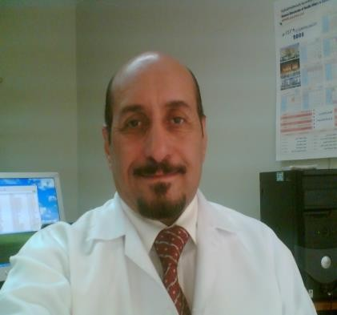
C.V Curriculum Vitae:
*FAIHQ, Fellowship of the American Institute Health Quality.
*CHQ, Health Care Quality Professional. AIHQ
* CBAHI Trainer, Quality Standards. *Surveyor, AIHQ, certified USA
*MSC, Hospital Management, Ein Shams University Egypt.
*MSC, Int. Medicine Cairo University Egypt.

Personal Data:
o Name: Bahie El Din El Hosiny Metwally
o Nationality: Egyptian. Free Lancer Resident as Husband of Saudi Citizen
o Current Job: Preparing hospitals for accreditation by CBAHI and JCI.
Quality Consultant at Rokaia Establishment for Hospital Operations.

Contact, Data:
drrrbahie@hotmail.com.
drbahie@gmail.com
Cell Phone: 0545699979
0560212195
.
Education &Qualification:
- CHQ, Healthcare Quality Professional 2014.Oklahoma USA
- FAIHQ, USA, Fellowship.2007 Oklahoma USA
- Hospital Accreditation Surveyor, AIHQ 2009
- Trainer CBAHI Standards 2013.
- Master (2Years) Hospital management, Egypt 2004.
- Master (Diploma) Medicine Egypt 2004.
- MBBS, Cairo University Egypt. 1974.

APPOINTMENTS AND POSITIONS:
  - Quality Department Director, Dhahran Eye Specialist Hospital, from2006.till 2017.
- Accreditation surveyor, AIHQ, USA, certified 2009~2016.
- CBAHI Standards Trainer 2015.
- Accreditation Team Leader at Rokaia Establishment for hospitals operations 2017
  - Medical Director, Nairyah General Hospital, 100Beds Hospital, From 2003.till 2005.

SKILLS:
- Accreditation, AIHQ, Certified JCI and CBAHI..
- MOCK Survey Skills shared in more than 20 mock surveys.
- Tracer skills and activities for Managerial and Clinical departments.
- Quality (leadership) trainer CBAHI, Certified.
- Developer hospital mission, vision, values, scope of service.
- OVR, FMEA, Near Miss, Sentinel events, RCA, SAC code skills.
- Programs developer, Quality, Risk management, and safety.
- Plans developer strategic, operational, safety and disaster plans
- Improvement projects FOCUS- PDCA methodology.
- Quality tools applications, and balanced card scoring.
- Quality implementation verification skills.
- Strategic Goals developing and monitoring.
- Quality standards trainer and compliance assessment.
- Resources care assessment, and equipments quality control.
- Cost effect analysis and cost reduction strategies assessment.
- Risk analysis, health care safety program assessment.
- Privileges review and Peer review skills.
SKILLS IN THE APPLICATION OF:
1. Quality Tools & Measures
2. Pareto Priority Scoring
3. Flow Charts
4. SWOT Analysis
5. Force Field Analysis
6. Sac Code
7. Score Cards
8. RCA, OVR, FMEA.
9. Fish Bone
10. FOCUS PDCA,
.SPSS, Classification Table ,Confusion Matrix ,Sensitivity and Specificity.

Responsibilities as a Quality Director:
- Pre and Post Accreditation Quality and Safety program..
- kaizen system, six sigma, and DMAIC performance improvement
- Effective team of professionalism and creativity.
- ESR requirements fulfillment program.
- Resources utilization and lean cost of operations and follow-up of the annual budget of the hospital.

- Data Standardization validity and reliability.
- Internal Audit Program both Clinical and Administrative to assure adherence, to Quality, Safety, and achieve Improvement.
- Professional attitude, no blame policy, and adopting smart goals.

AUTHOR EXPERIENCE OF HOSPITALS CBAHI ACCREDITED:
* Balshrahil Hospital Holly Mecca 2018
*Al Hyatt Hospital – Jeddah 2017
* Dar Al Shefa Hospital- Riyadh 2017
* JCI Accreditation Dhahran Eye Specialist Hospital Eastern Region 2016.
* CBAHI Accreditation Dhahran Eye Specialist Hospital 2017.
* ESR survey with 91% excellence score in all hospitals 2017.

PUBLICATIONS:
1. ESR guide 2016
2. Quality Management 2015
3.Safety Surgical Check List 2015

FELLOWSHIPS:
- Saudi Quality Association
- FAIHQ, USA, Fellowship 2008,
- Canadian Quality Association 2006.
- Saudi Nephrology Club 2003.
Quality Forum National Guard Hospital, Eastern Region.

PROJECTS:
    - Prize of prince Mohammed Bin Fahd for Quality in Hospitals 2008
    - Safety Performance Improvement Plan at King Fahd Airport Eastern Region.
    - Resources Monitoring And Measures Military Hospital Eastern Region .
    - Hospital Balanced Score Card Monitoring Dhahran Eye Specialist Hospital.
    - Quality Culture Building, Values Of Loyalty Dammam Medical Complex.

INTERNATIONAL CONFERENCES:
International quality and safety conference Paris 2014
International quality and safety forum Frankfurt 2012
International Quality and safety forum Bin Hamad University Dubai 2011
International quality and safety forum UK 2010

LECTURES ,WORKSHOPS CARRIED ON BY THE AUTHOR:
.
o Effective Team Work
o Strategic and Operational Plans
o Strategic Goals.

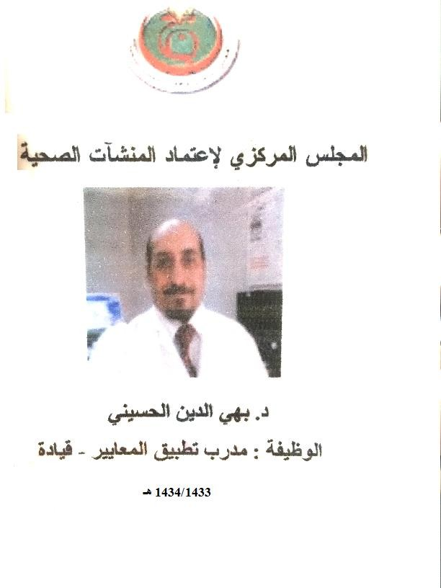
o Quality Tools
o OVR, RCA and FMEA, Analysis.
o Information Management
o Effective Meetings and Decisions.
o Risk Management
o Quality Monitoring
o Quality Dimensions
o Patients Rights
o FOCUS –PDCA.
o Resistance to change.
o Health Safety.
o. Hospital Mock Survey.

COMPUTER SKILLS:

- Quality and risk management software.
- Data management Software of.
- Microsoft and office
- Graphical software's
- Database programs.

